Identity & Access Management (IAM)

LAB Architecture

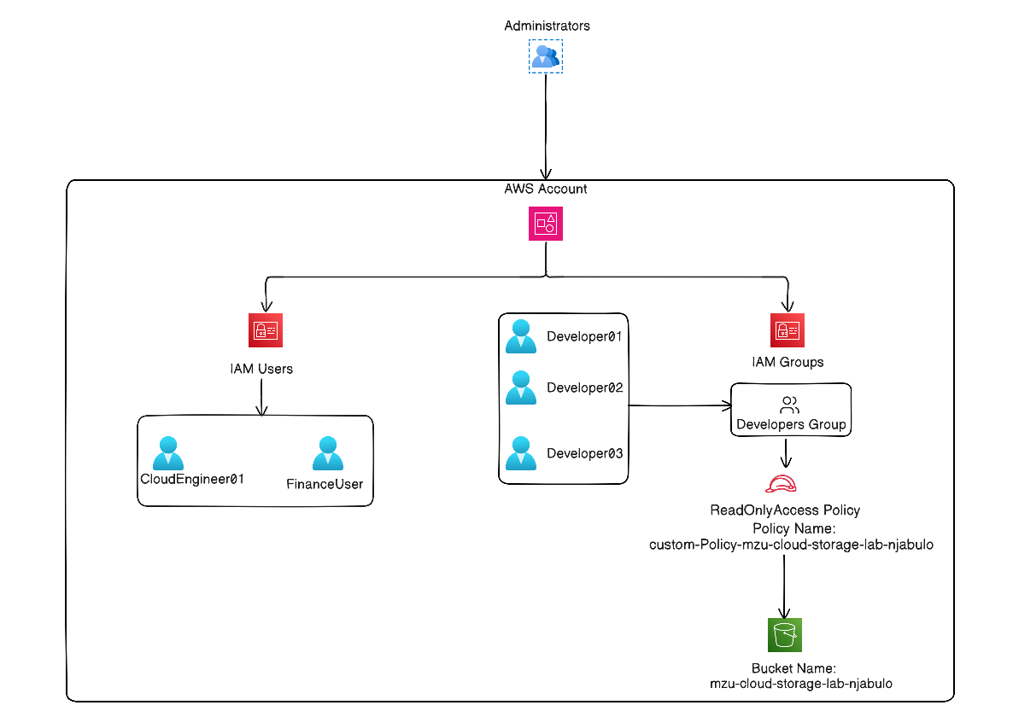

Task 1 - Navigate to IAM
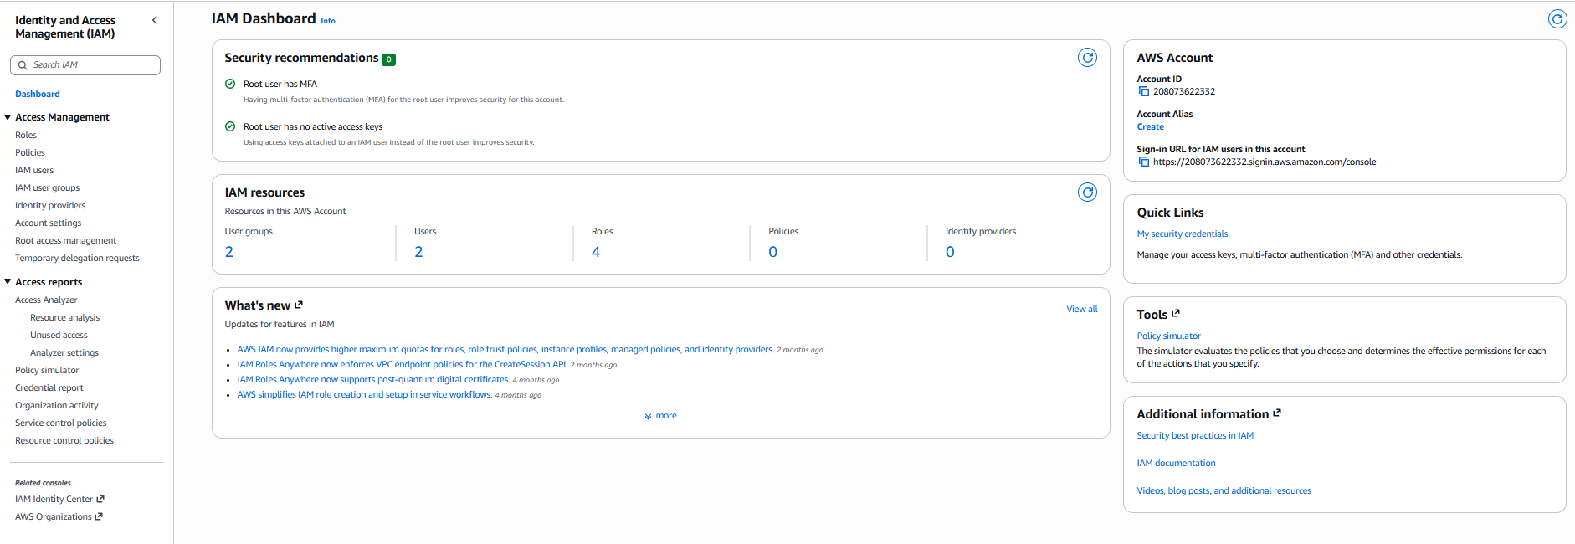

Task 2 - Create an IAM User
Username:
- CloudEngineer01

Task 3 - Create a Second User
Username
- FinanceUser01
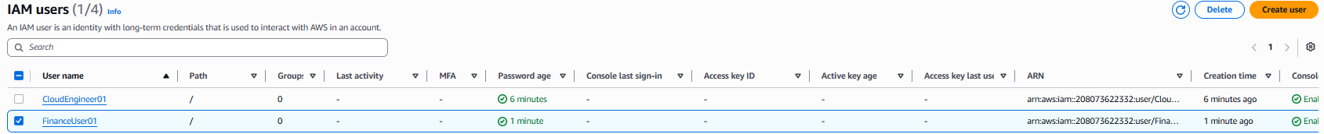

Task 4 - Create an IAM Group
Group Name
- Developers
Attach the AWS Managed Policy
- ReadOnlyAccess
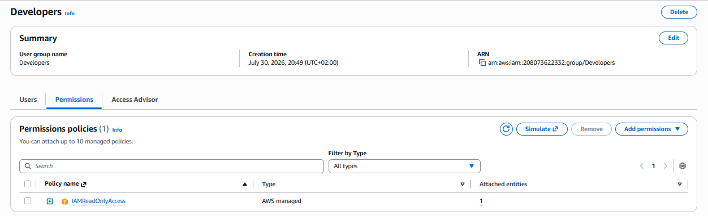

Task 5 – Add Users to the Group
Open
- Developers Group
Choose
- Add Users
Select
- CloudEngineer01
Save

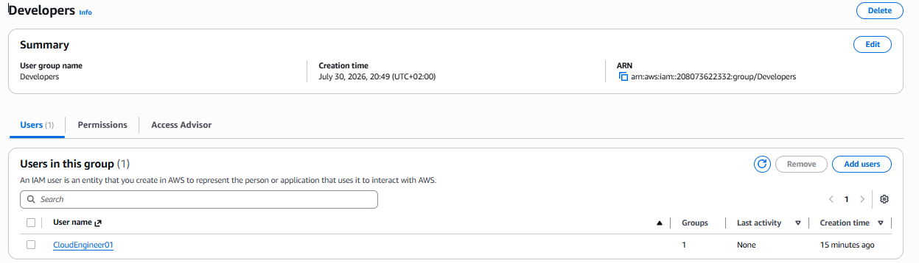
Verify
- CloudEngineer01 has ReadOnlyAccess permission
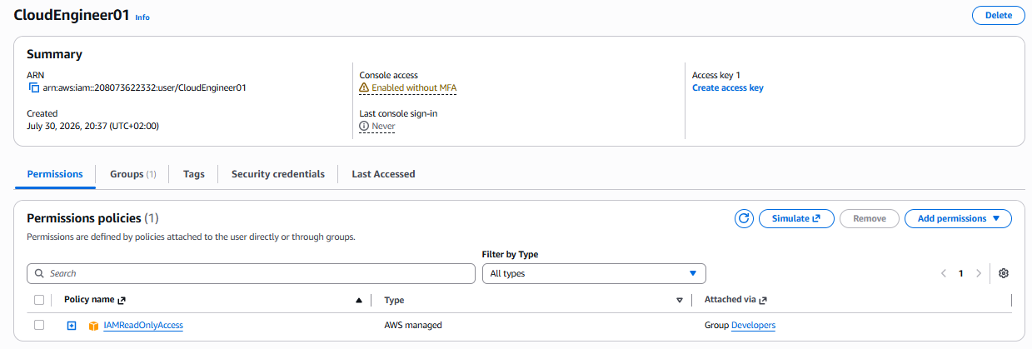

Task 6 – Review AWS Managed Policies

Task 7 – Create a Custom Policy (Optional)
Custom-managed Policy that allow readd-only access to a single S3

{
"Version": "2012-10-17",
"Statement": [
{
"Effect": "Allow",
"Action": [
"s3:GetObject",
"s3:ListBucket"
],
"Resource": [
"arn:aws:s3:::mzu-cloud-storage-lab-njabulo",
"arn:aws:s3:::mzu-cloud-storage-lab-njabulo/*"
]
}
]
}

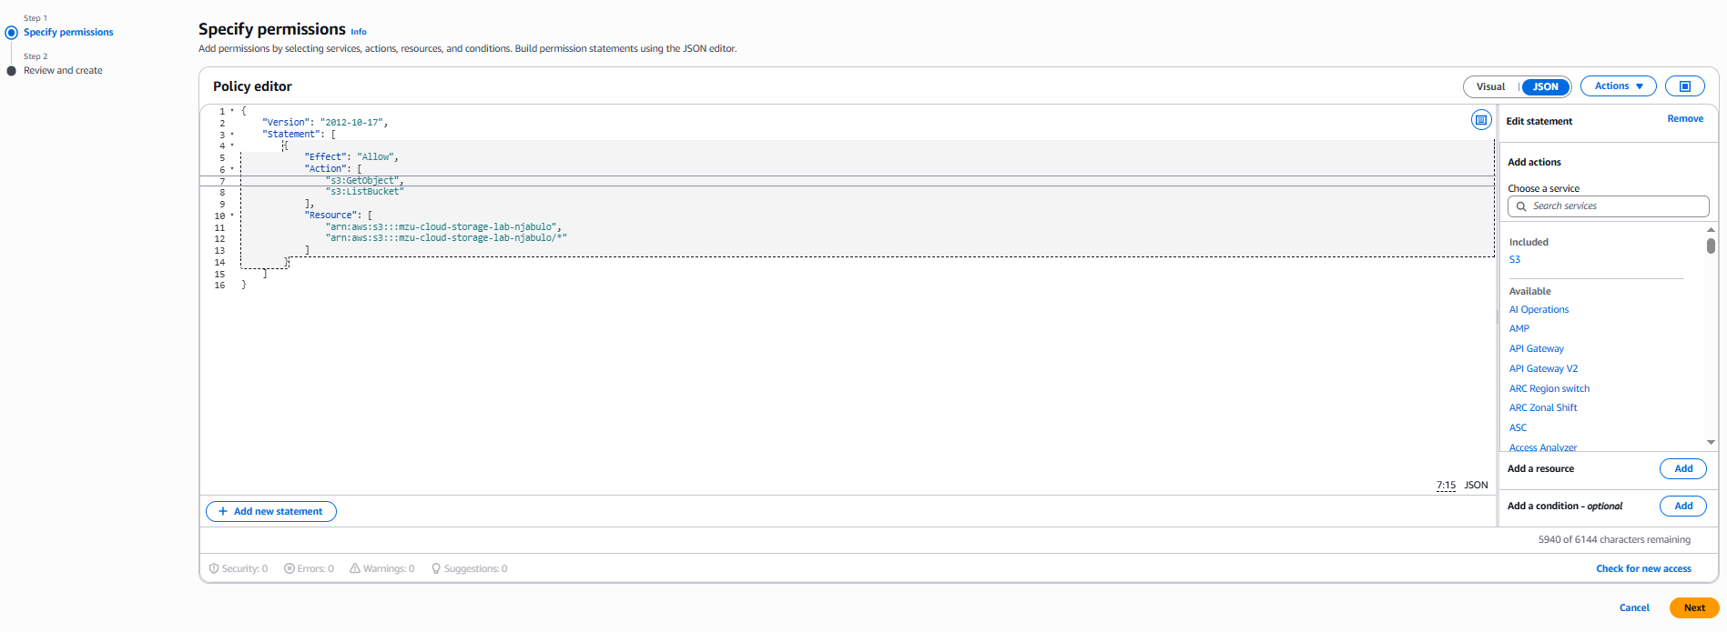

Customer Policy name
- custom-Policy-mzu-cloud-storage-lab-njabulo
Policy Created
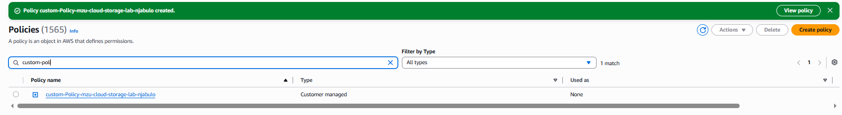

Task 8 - Enable Multi-Factor Authentication
User
- CloudEngineer01
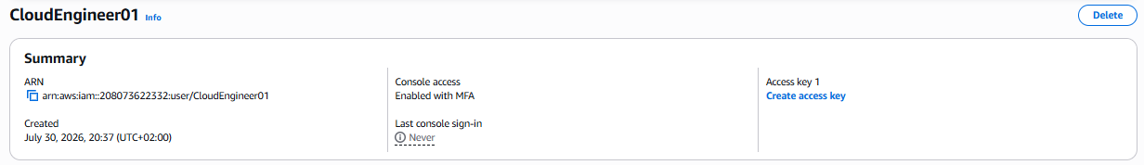

Task 9 – Create an IAM Role
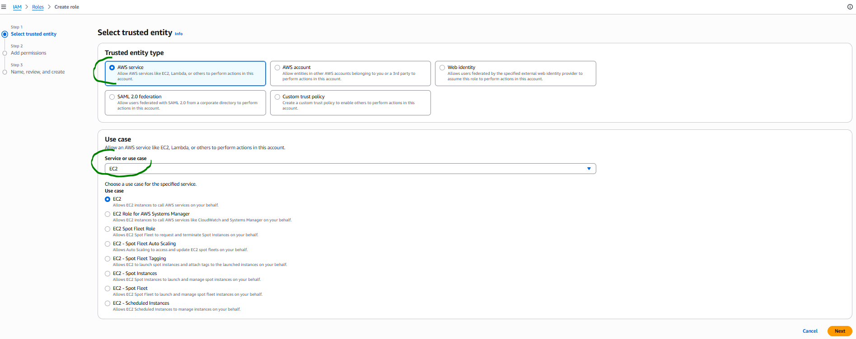
Attach the AWS Managed Policy
- AmazonS3ReadOnlyAccess
Role Name
- EC2-S3-ReadOnlyAccess-Role
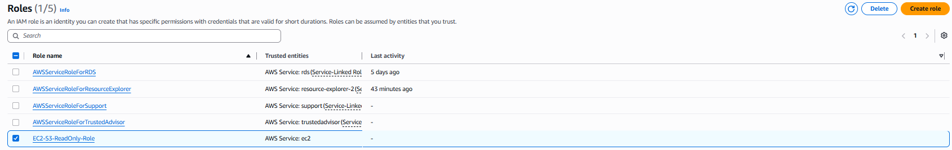

Assigned CloudEngineer01
- custom-Policy-mzu-cloud-storage-lab-njabulo

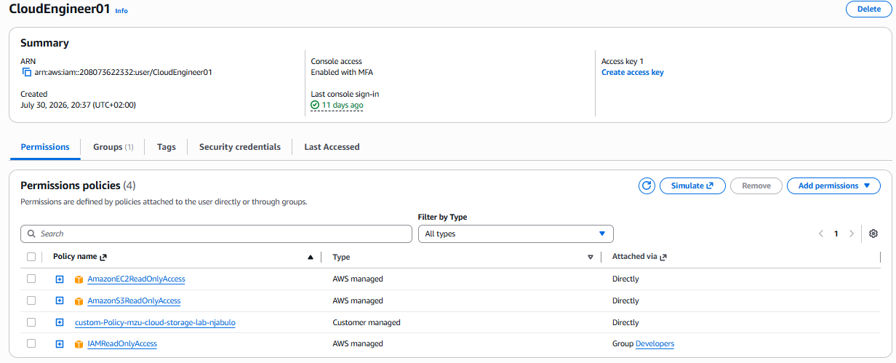

Task 10 – Permission Investigation
Question 1
- Can CloudEngineer01 delete an S3 bucket? No
- User not granted rights to delete or modify the S3/objects etc ect
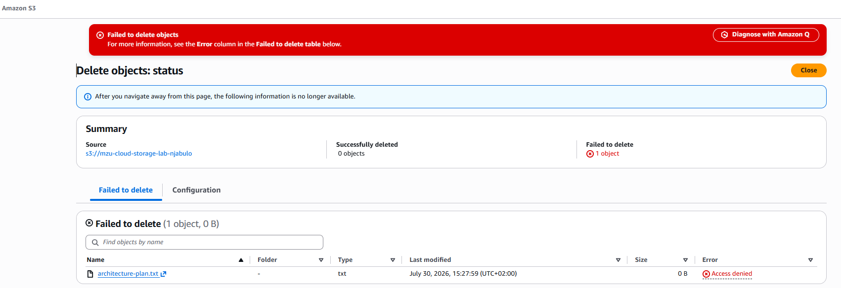
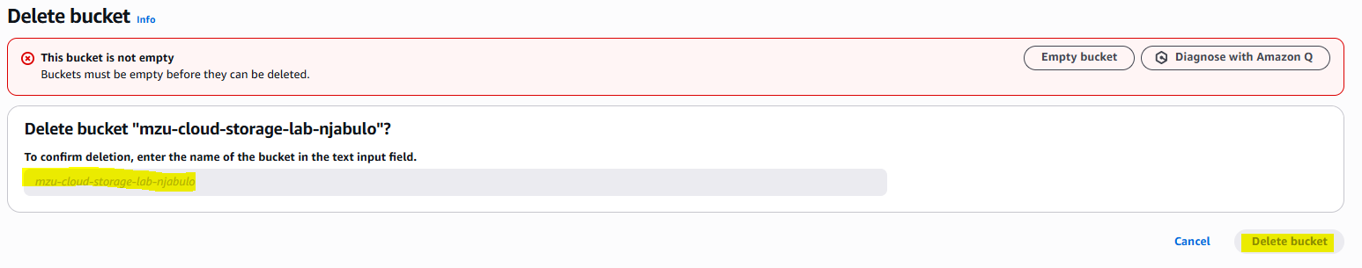

Question 2
Can CloudEngineer01 view EC2 instances?
Answer: No – if the instance is stopped CloudEngineer01 can not start it.
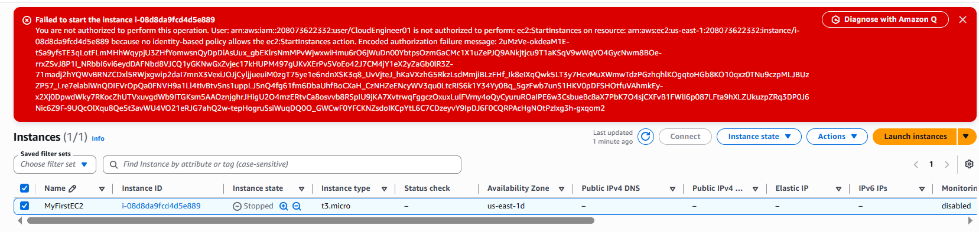

Challenge Lab
Create Users
- Developer01
- Developer02
- Developer03
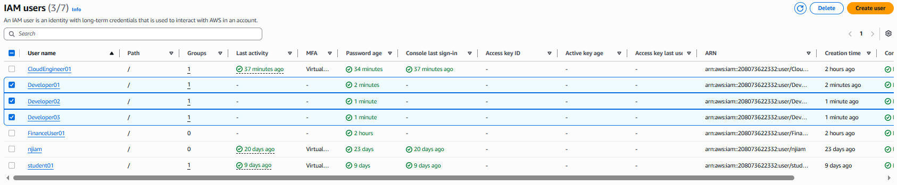
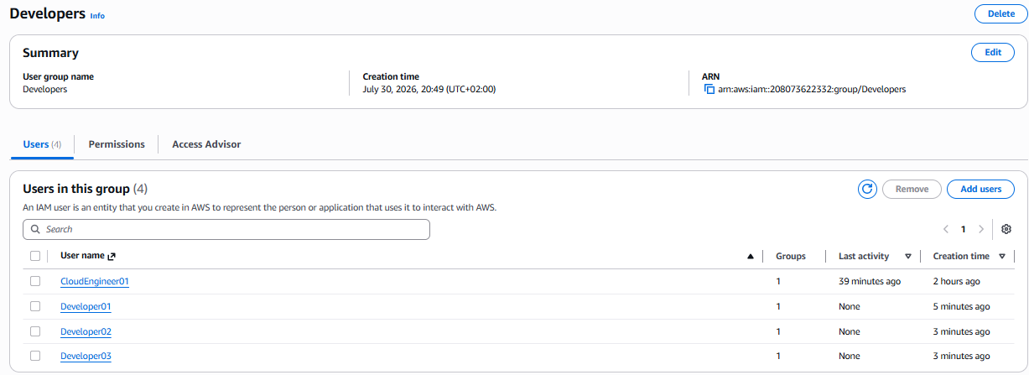

Assign - all dev users
- Developers (ReadOnlyAccess)
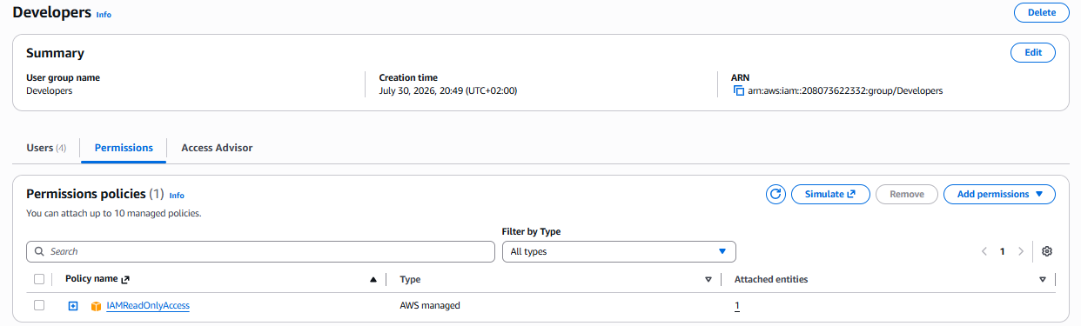

Bonus Challenge
Create IAM Group
- Administrators
Assign
- AdministratorAccess
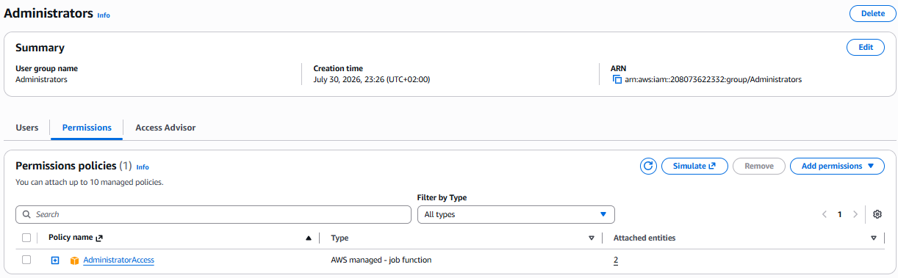

Discussion: small number of users are granted admin-access
- Only trained users are granted admin access to perform admin related e.g. creating user profile and to prevent accidental changes and making it easy to track activity/ actions.

